**Title:** A review of waste heat recovery technologies for maritime applications

**Author(s):** Dig Vijay Singh, Eilif Pedersen

**Published:** Energy conversion and management, 20-December-2015

**Keywords:** Waste heat recovery; Marine diesel engine; Turbocharger; Thermodynamic cycles; Thermo-electrics

Singh and Pederson explore efficiencies of several waste heat recovery systems in order to reduce emissions of marine vessels. They assert that approximately 50% of the total fuel energy supplied to an onboard diesel plant is lost to the vessel’s surroundings. Some of the methods they explore are:

1. Rankine cycle
   1. Steam/conventional
   2. Organic
   3. Super-critical
2. Kalina cycle
3. Exhaust gas turbine system
   1. Hybrid turbocharger
   2. Mechanical turbo-compound system
   3. Hydraulic turbo-compound system
   4. Electrical turbo-compound system
4. Thermoelectric generation systems

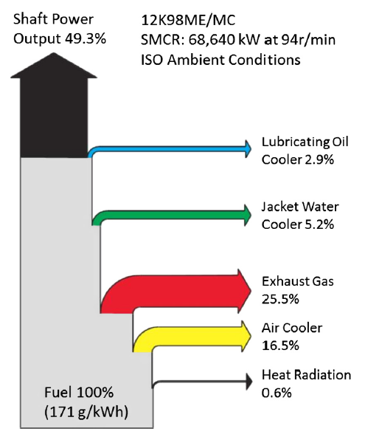

Figure : Heat balance diagram for MAN 12K98ME/MC marine diesel engine operating at 100 SMCR under ISO conditions

This study defines waste heat grades and temperatures for the sake of discussion on whether certain sources can be economically harnessed. Engine cooling water temperatures of 80-90 oC are fairly standard for most engines.

This study primarily examined harvesting waste heat from the exhaust stream as the temperature and quality of that heat stream. However, jacket water heat is large in quantity and continuously available during engine operation which makes it a good candidate for a suitably chosen WHRS. Chosen especially for dealing with low quality waste heat.

Power cycles discussed in this study are:

1. Rankine cycle
2. Organic Rankine cycle
3. Supercritical Rankine cycle
4. Kalina cycle

The study acknowledges that the installation of WHRS is more feasible in new-build vessels but discusses installation in existing vessels as well.

The study characterizes several different variants of the Rankine cycle including special attention to the more common variants named for their working fluid such as steam Rankine cycle (SRC) and organic Rankine cycle (ORC). ORCs being explained in more detail due to their unique applicability to low temperature specific vaporization heat of organic fluids such as hydrochlorofluorocarbons (HCFSs) fossil fuels (Propane) and refrigerants (R134a, R22, R245fa). Conversion efficiency of 8% - 12% for the temperature range of 95oC - 260oC.

For low and medium temperature WHR wet fluids are not particularly desirable due to the lack of superheating capability of the source and can cause condensation leading to turbine erosion. Dry, isentropic and slightly wet fluids are the promising candidates for ORC applications. For ORC applications a simple single stage turbine can be used because of the smaller temperature difference between evaporation and condensation. SCRC systems offer even better efficiency because they heat the working luid in the evaporator at a pressure lower than the critical pressure of the working fluid which bypasses the two-phase region resulting in less exergy destruction.

The Kalina cycle is a modified form of an RC and has a better operating efficiency in certain applications. Most significant gains were obtained in cycles with low temperature heat sources. Within the temperature range 200oC – 400 oC the KC is 20% - 40% more efficient than RC. Some studies showed that KC had better thermodynamic performance than ORC as well. 20% - 25% A KC plant has been successfully operating using geothermal fluid as a source at Husavik, Iceland. KC uses ammonia-water mixture as a working fluid which is considered safe and environmentally friendly. It is also widely used in the industry with very mature safety standards.